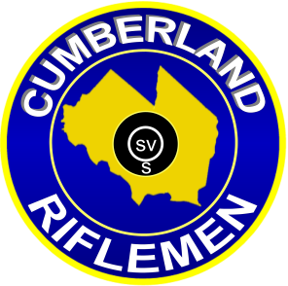
2015
NRA Registered High Power Rifle
Mid-Range/F-Class
New Jersey State Championship

Date: Saturday: September 5

Location: Cumberland Riflemen, Inc.
4030 East Main Street (Route 49)
Millville, New Jersey 08332

Directions can be found at WWW.Cumberlandriflemen.com For New Jersey

Firearms Transportation Laws: http://www.state.nj.us/njsp/about/fire_trans.html

Competition: Open to all.

Rules: Current NRA High Power Rifle rules will apply.

Rifles Allowed: Rifles allowed for record firing: Any Rifle/Any Sight and Service Rifle Service Rifle- Rule 3.1 a through e; Any Rifle- Rule 3.2; Rifle- Rule 3.3; Palma Rifle- Rule 3.3.1; Any Sight Rifle/Tactical Rifle- Rule 3.3.2; F-Class- Rule 3.4 (a), (b)
No compensators or muzzle brakes allowed – Rule 3.16.1
Ammunition restricted to no larger than .35 caliber – Rule 3.2
Classification: The NRA High Power Classification system will be used.

Categories: Match Rifle, Service Rifle and F-Class.
A minimum of 5 shooters is required to form a class/category.
Classes and/or categories will be combined if less than 5 shooters per class/category.

Awards: Awards will be given in each category and class.
Awards will be given in each multiple of 5.
Competitors may not win more than one award in each match.
Must be a member of the Association of New Jersey Rifle and Pistol Club (ANJRPC) to be awarded State Champion

Note: Competitors using a scope on the MR-1 target will be ineligible for awards. However, if 5 or more competitors compete with a scoped rifle on the MR-1 target, they form a class; therefore become eligible to win individual matches 1, 2, 3, and aggregate in that newly formed class only. Classifications in this class will be combined.

Registration: 0800 -0845. Firing commences promptly at 0900.

Entry Fees: $30.00 Juniors under 21 $20.00

Challenges: $2.00 per challenge LOST.

Match Director: Gwen Schallow Contact at 609-992-6816 or Woodgunguy@Comcast.net

Course of Fire:
Match #1 600 yard slow fire. 2 sighters with 20 rounds for record. Time limit of 22 minutes
Match #2 600 yard slow fire. 2 sighters with 20 rounds for record. Time limit of 22 minutes
Match #3 600 yard slow fire. 2 sighters with 20 rounds for record. Time limit of 22 minutes
Match #4 Aggregate of Matches 1, 2, and 3.

