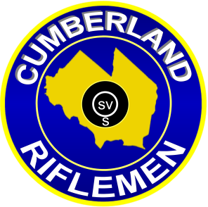
2015
NRA Approved High Power Rifle
National Match Course
Tournament Schedule

Dates: Sunday: April 12, May 3, June 7, July 5, August 2, October 4

Location: Cumberland Riflemen, Inc.
4030 East Main Street (Route 49)
Millville, New Jersey 08332
Directions can be found at WWW.Cumberlandriflemen.com

For New Jersey Firearms Transportation Laws: http://www.state.nj.us/njsp/about/fire_trans.html

Competition: Open to all.

Rifles Allowed: Service Rifle – Rule 3.1, a through e: Match Rifle – Rule 3.3:
Classification: The NRA High Power Classification system will be used.

Categories: A minimum of 5 shooters is required to form a class/category.
Classes and/or categories will be combined if less than 5 shooters per class/category.

Awards: Awards will be given in each category and class.
Awards will be given in each multiple of 5.
Competitors may not win more than one award in each match.

Registration: Registration from 0700 -0745
Firing commences promptly at 0800.

Entry Fees: $30.00 Juniors under 21 $20.00

Challenges: $2.00 per challenge LOST.

Match Director: Mike Berezin Contact at mberez223@msn.com

Course of Fire:
Match #1 200 yards standing slow fire. 2 sighters and 20 rounds for record. NRA rule 5.12. (22 minutes time limit) SR target.

Match #2 200 yard rapid fire, sitting or kneeling. 2 sighters and 20 rounds for record. Two ten shot strings. NRA rules 5.8, 5.10 (time limit per NRA rule 8.2b) SR target.
Match #3 300 yard rapid fire prone. 2 sighters and 20 rounds for record. Two ten shot strings. NRA rules 5.6 (time limit per NRA rule 8.2b) SR-3 target.

Match #4 600 yard prone slow fire. 2 sighters and 20 rounds for record. NRA rule 5.6 (22 minute time limit. NRA rule 8.2a) MR-1 target.

Match #5 Aggregate of matches 1, 2, 3, and 4.

